 Project Report Template

# 1 INTRODUCTION

* 1. Overview

Analyzing Spending Behavior and Identifying Opportunities

for Growth" is a strategic process that involves studying

consumer spending patterns and behavior to uncover

potential opportunities for business expansion and

development. This analysis helps businesses make informed

decisions to target their products or services effectively and

achieve sustainable growth in the market.

* 1. Purpose

This project will be useful in analyzing the spending behavior of the people and Identifying the opportunity for the growth. The number of consumers will be identified. The brand of high and popular sale will also be known.

**2 Problem Definition & Design Thinking**

2.1 Empathy Map

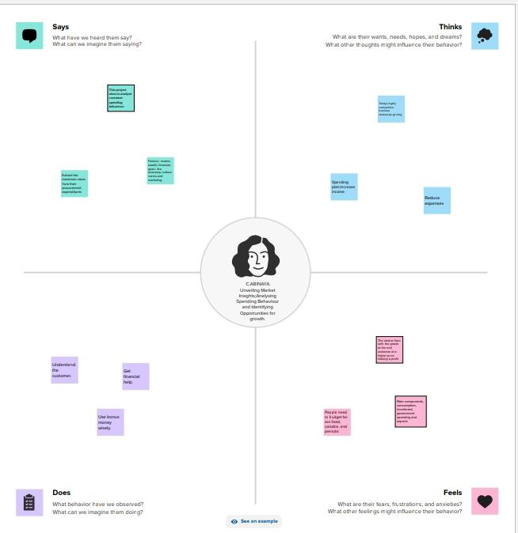

2.2 Ideation & Brainstorming Map

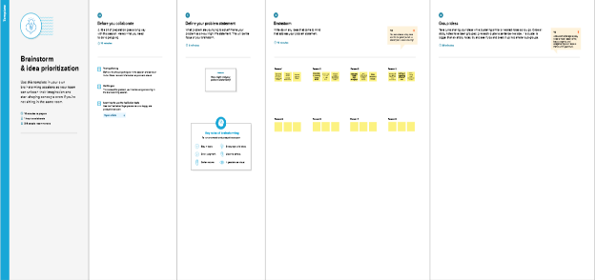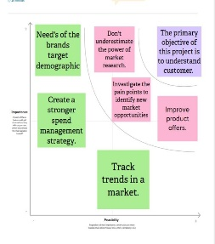

# 3 RESULT

Consumer Spending Behavior by CategoryBar chart displaying

consumer spending patterns across different categories (e.g., food,

electronics, clothing).Seasonal Spending TrendsLine graph showing

how spending behavior varies throughout the year.Demographic

AnalysisPie chart illustrating spending behavior by age

group.Geographic InsightsHeatmap or map visualizations showing

regional variations in spending.Opportunity MatrixA matrix table

summarizing identified growth opportunities with brief

descriptions.

# 4 ADVANTAGES & DISADVANTAGES

**Advantages**

1.Uncover saving opportunities

2.Reduce costs

3.Inform decision making

4.Create a stronger spend management strategy

5.Manage risk

**Disadvantages**

1.Required significant time investment

2.Disadvantages of a market includes are inequality,negative

externalities

3.Lack of public goods

4.India faces several challenges including the lack of data,

funding,infrastructure,language etc.,

5.Wide social and economic gap

# 5 APPLICATIONS

1.New product developments into :new -to-the-company,

improvement of existing product ,extension of product line, and

new -to -the -market.

2.A consumer product is a finished product available for sale to a

customer.

# 6 CONCLUSION

Marketing research is crucial for ensuring that a company can

understand the mindset of its customers. Based on the findings of

these reports, they can develop products that can fulfill customers'

requirements.

# 7 FUTURE SCOPE

Ethical Consideration:As data privacy and ethical concerns grow,

the future of this field will involve balancing in-depth consumer

insights with respect for privacy and compliance with data

protection regulations.Global Markets: As businesses expand

globally, understanding diverse spending behaviors across cultures

will be essential for market entry and success.

# 8 APPENDIX

1. Executive Summary: A concise summary of key findings, opportunities, and recommendations.
2. Data Analysis: Detailed analysis of spending behavior, including trends, patterns, and key insights.
3. Market Segmentation: Information on how different consumer segments behave in terms of spending
4. Conclusion: A summary of the main takeaways and the potential impact on the business.

 Project Report Template